# Compiling, information gathering, and debugging

## Summary

In this class exercise, we will introduce you to the compilation process, information gathering on binaries, and debugging.

## Prerequisites

* Ubuntu Linux VM
* Eclipse

## Details

* Discuss the graphic below with your group
  + Discuss the chronological steps (boxes)
  + Discuss the artifacts generated in each phase (items listed at top)

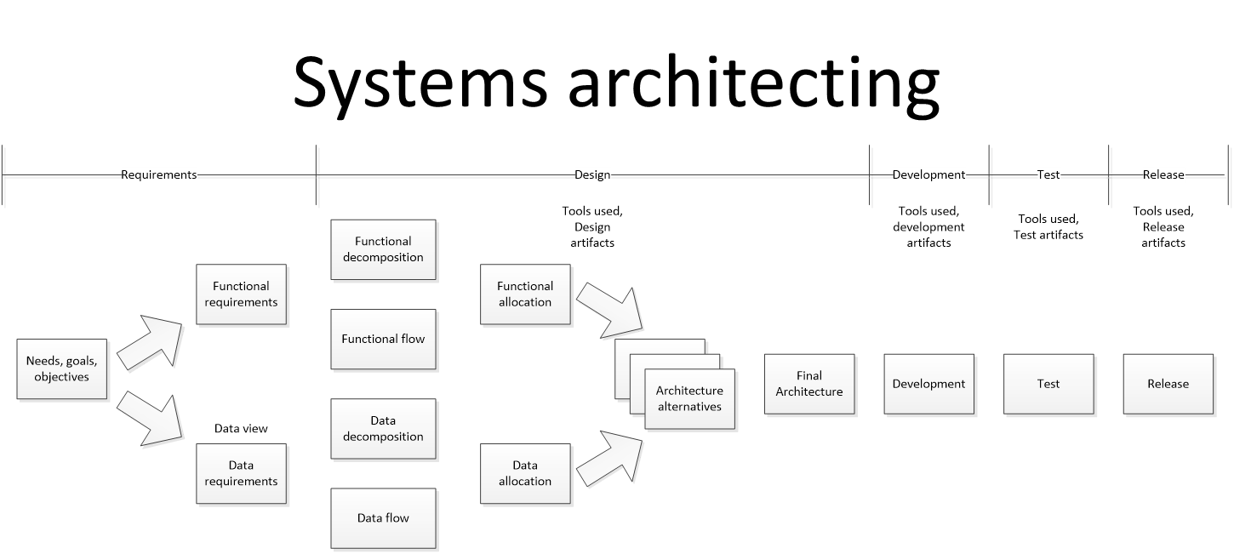

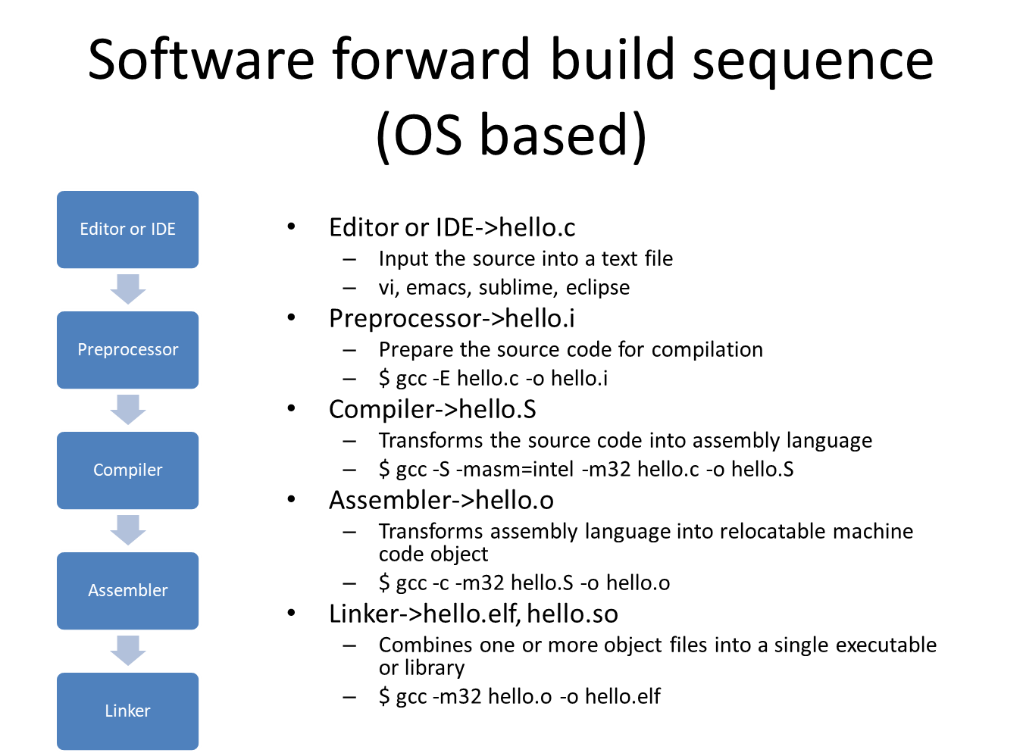

* Create the code below and run each of the gcc steps in the comments
* Inspect the results and discuss with your group

|  |
| --- |
| #include <stdio.h>  //Run the preprocessor  // $ gcc -E hello.c -o hello.i  //Compile the source code into assembly language  // $ gcc -S -masm=intel -m32 hello.c -o hello.S  //Assemble into machine code  // $ gcc -c -m32 hello.S -o hello.o  //Run the linker to construct *.elf  // $ gcc -m32 hello.o -o hello.elf  int main()  {  // printf() displays the string inside quotation  printf("Hello, EN.650.660 students!");  return 0;  } |

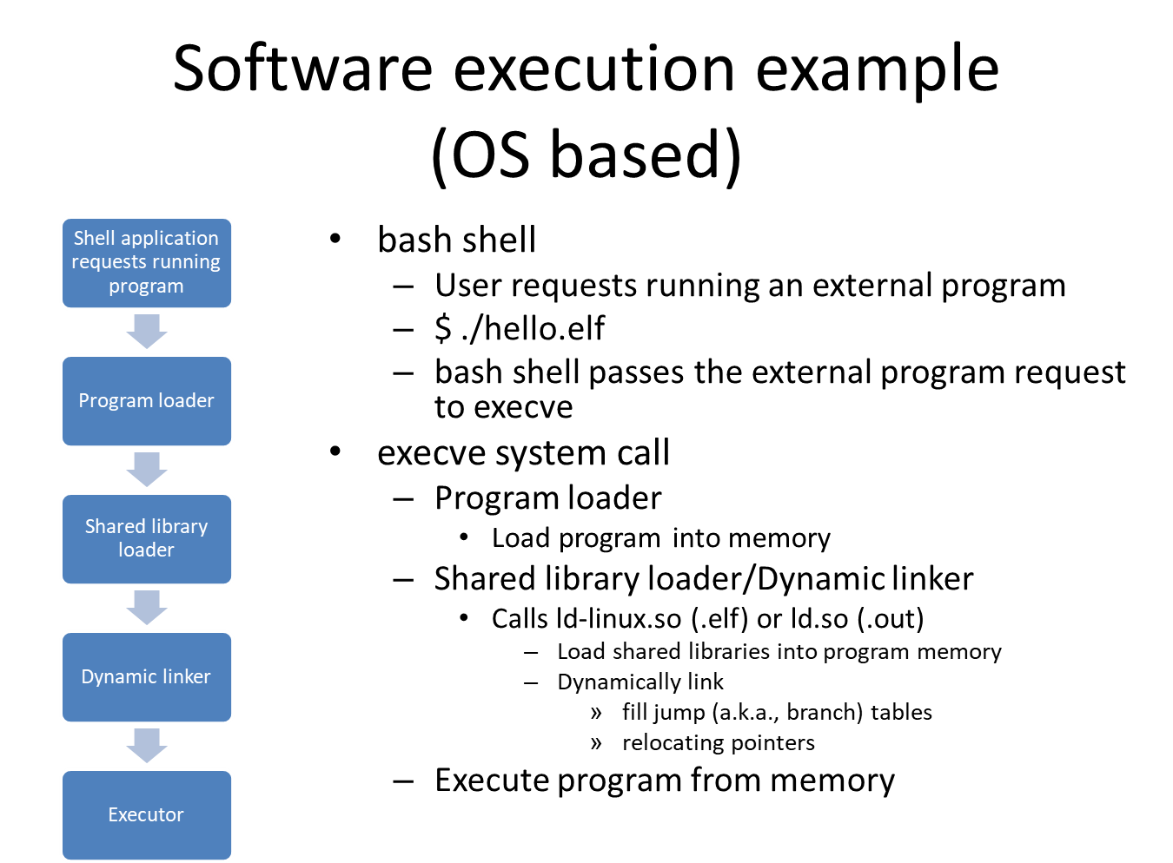

* Run the previous binary in the debugger
* Create a binary that has debugging symbols and run this in the debugger
  + $ gcc -m32 hello.c -g -O0 -o hello.elf

### Definitions

* N/A